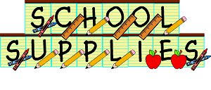
Mrs. Smith’s 3rd Grade

All Students:

1 Backpack (non-rolling)
1 Box of Crayola crayons (up to 24 count only)
1 Box of thick washable Crayola markers
1 Box of Crayola colored pencils
3 Glue sticks
48 yellow #2 pencils (non-mechanical)
2 Red ink pens
2 Large pink erasers
1 pair of blunt scissors
3 Solid colored pocket folders (plastic preferred)
1 Wide ruled spiral notebook
1 Package of wide ruled notebook paper
2 Containers of antibacterial cleaning wipes (Clorox or Lysol type wipes)
2 Packages of wet wipes for hands
1 8 oz bottle of hand sanitizer
3 Boxes of tissues
3 Rolls of paper towels
1 Package of Expo white board markers

Voluntary Donations:

Treasures for the treasure box
Zip Lock plastic bags (sandwich, quart, and gallon sizes)

* Students will have a basket to use for their supplies*

